How To Format Manuscript For Journal
Corresponding Author^{1 †}, Second Author^{1‡}, Third Author^{2§}
¹Name of Department, Institute or Organization Name, City, State, Country
²Name of Department, Institute or Organization Name, City, State, Country
†Email corresponding author1
‡email author2
§email author3
Abstract
Your abstract should give readers a brief summary of your article. It should concisely describe the contents of your article. The abstract should be complete in itself, it should not contain undefined acronyms/abbreviations and no table numbers, figure numbers, references or equations should be referred to. The abstract should be suitable for direct inclusion in abstracting services and should not normally be more than 300 words.
Keywords: PSC.

Introduction
This should be concise and describe the nature of the problem under investigation and its background. It should also set your work in the context of previous research, citing relevant references. Introductions should expand on highly specialized terms and abbreviations used in the article to make it accessible for readers [1].
Method
The results section should detail the main findings and outcomes of your study. You should use tables only to improve conciseness or where the information cannot be given satisfactorily in other ways such as histograms or graphs. Tables should be numbered serially and referred to in the text by number (Table 1).
Table 1: Caption of the table replace here
Column Header Goes Here | Column Header Goes Here | Column Header Goes Here
Row Name Here | x | x
Row Name Here | x | x
Each table should have an explanatory caption which should be as concise as possible. Equations should be centered with equation numbers on the right-hand side (flush right).
y = mx + c (1)
Discussion
This should discuss the significance of the results and compare them with previous work using relevant references. Carefully chosen and well-prepared figures, such as diagrams and photographs, can greatly enhance your article. You are encouraged to prepare figures that are clear, easy to read and of the best possible quality and resolution.
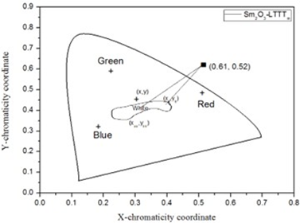
Figure 1: Mention figure caption here
Captions should be included in the text. Figure captions should contain relevant key terms and be self-contained (avoiding acronyms) so that a reader can understand the figure without having to refer to the text. Figure captions should also reference the source of the figure if the figure has been reused from elsewhere Figure 1.
Conclusion And Future Prospective
This section should be used to high light the novelty and significance of the work, and any plans for future relevant work.
References
- C D Smith and E F Jones. Load-cycling in cubic press,” in Shock Compression of Condensed Matter-2001. AIP Conference Proceedings, 620:651–654, 2002.
- M P Brown and K Austin. Appl. Phys. Letters, 85:2503–2504, 2004.
- B R Jackson, T Pitman, and U S Patent, 2004.
- R T Wang. Title of Chapter. Classic Physiques, pages 212–213, 1999.
- M P Brown and K Austin, The New Physique, 2005.
- R C Mikkelson.
- D L Davids, Recovery effects in binary aluminum alloys, 1998.

